**Excel Assignment - 6**

**1. What are the various elements of the Excel interface? Describe how they're used.**

**Excel's** user interface revolves around the ribbon, a bar of controls across the top of the application window. The ribbon consists of tabs that contain groups of controls, and the term is used to identify the location of tools.

keyboard shortcut Alt+I+N+A works in all versions of **Excel**.

Select the required range name in the dialog box that appears and the formulas in the active worksheet will be updated accordingly.

The different components of MS **Excel** are File Menu, Quick Access Toolbar, Title Bar, Row Headers, Column Headers, Active Cell (the cell you put the cursor in), and Fill Handle, address bar, formula bar, worksheet tabs, status bar

**2. Write down the various applications of Excel in the industry.**

Data entry, Data management, Accounting, Financial analysis, Charting and graphing, Programming, Time management, Task management.

**3. On the ribbon, make a new tab. Add some different groups, insert commands in the groups and name them according to their commands added. Copy and paste the screenshot of the steps you followed.**

Open the "Customize the Ribbon" window

To work with your ribbon, you need to get to the Customize the Ribbon window. Here's how you do that.

-Open the app you want to customize your ribbon in Excel.

-Place your mouse in any empty space in the ribbon and then right-click.

-Click Customize the Ribbon

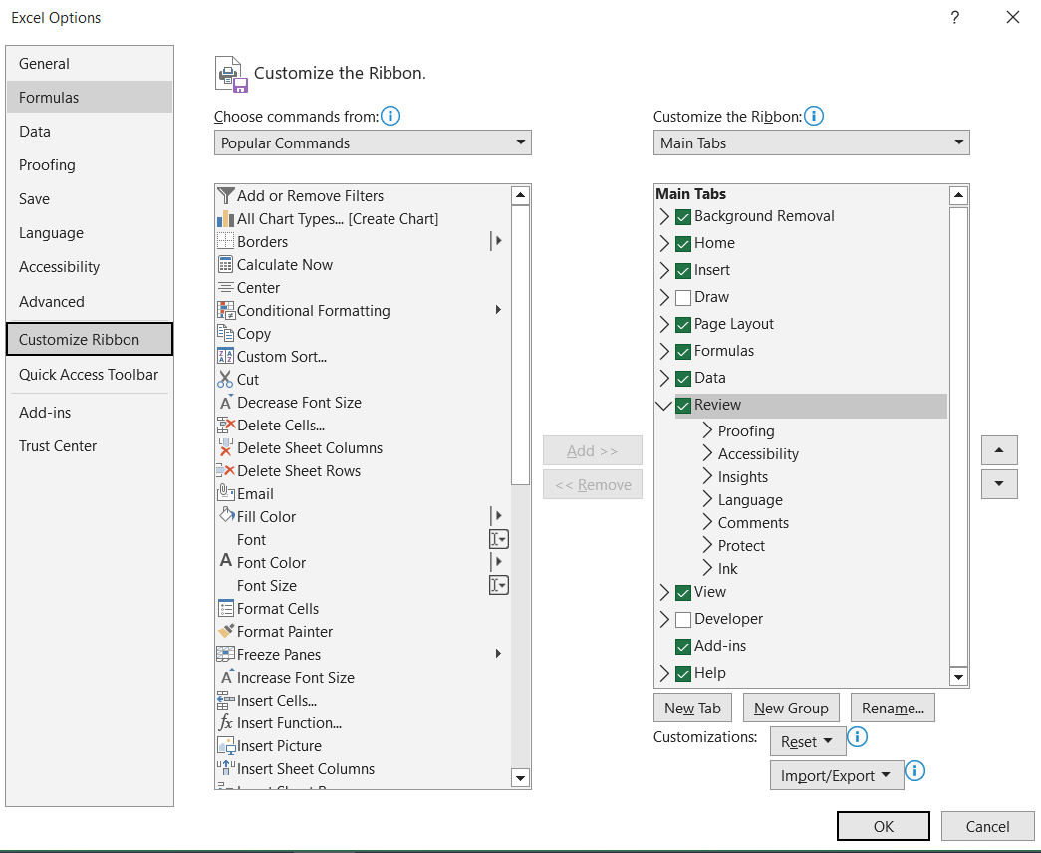

**4. Make a list of different shortcut keys that are only connected to formatting with their functions.**

Ctrl+C → Copy selected text or graphics.

Ctrl+V → Paste the most recent addition.

Ctrl+Shift+A → Format all letters as capitals.

Ctrl+B → Applies or removes bold formatting.

Ctrl+Shift+H → Hide the selected text.

Ctrl+B→ Apply bold formatting.

Ctrl+Shift+L→ Add a bulleted list

Ctrl+U→ Apply underline formatting.

**5. What distinguishes Excel from other analytical tools?**

Excel doesn't have a learning curve, so time to insight is usually fast. It is a spreadsheet package that greatly helps in data analysis and documentation.

Numerous schedules and calculations that traditional bookkeeping software doesn't provide. we can do a lot of things with Excel: modelling, visualization, reports, dynamic charts, etc. It can help you understand the meaning of many operations before further learning other tools.

6. Create a table and add a custom header and footer to your table.

Go to Insert > Header or Footer.

Choose the header style you want to use.

Add or change text for the header or footer. For more info on things you can do with headers, see [Edit your existing headers and footers](https://support.microsoft.com/en-us/office/edit-your-existing-headers-and-footers-490423a3-3e5b-4080-aff0-c429ab5d6708). To edit a header or footer that's been already created, double-click on it.

To eliminate a header--like deleting it on the title page--select it and then check the Different First Page box.

Select Close Header and Footer or press Esc to exit.

